# **IP Address**

**What Is An IP Address?:**

* An IP address is a unique address that identifies a device on the internet or a local network.
* IP addresses are the identifier that allows information to be sent between devices on a network: they contain location information and make devices accessible for communication.
* An IP address is not fixed. It will change when you switch to a different network.

**Steps To Check IP Address On Windows:**

1. Open CMD.

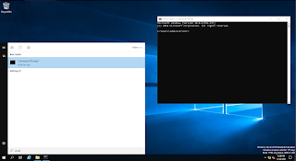

1. Type ipconfig.

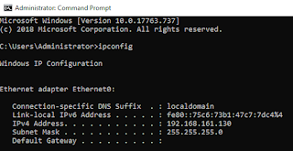

1. IPv4 is your server IP address.



**Steps To Check IP Address On CentOS Linux:**

1. Open terminal or access CentOS Linux by using putty.
2. Type ip addr.

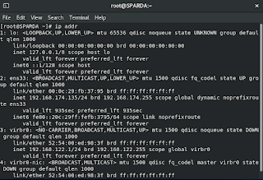

1. inet is your IP address.

